**Name : Ahmad**

**Roll No : 233605**

**Lab #04 : Visual Programming**

**Exercise # 4.9:**

1. **Initialize a two-Dimensional array of integers and pass to Print2DArray**

**Method. The method displays the elements of the array.**

**Input :**

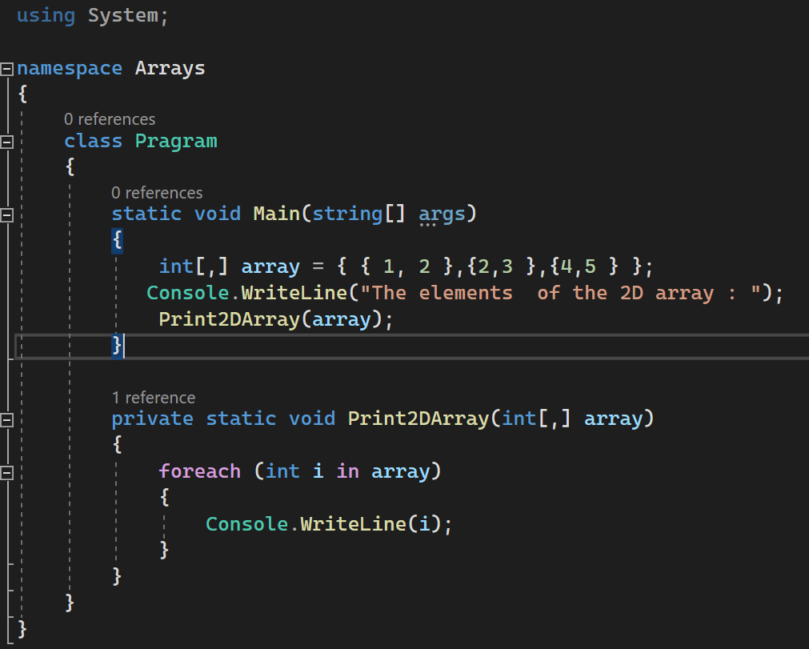

**Output** :

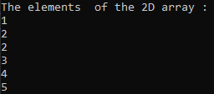

**2. Create a method named Merger which takes an array of type string as an argument. It combines all elements of string into one string and returns it.**

**For example: String which is passed contain following items:**

**string[]"hello", "and", "welcome", "to", "this", "demo! Mergerts) returns "hello and welcome to this demo Hint: Concat method can be used to solve this problem.**

**Input:**

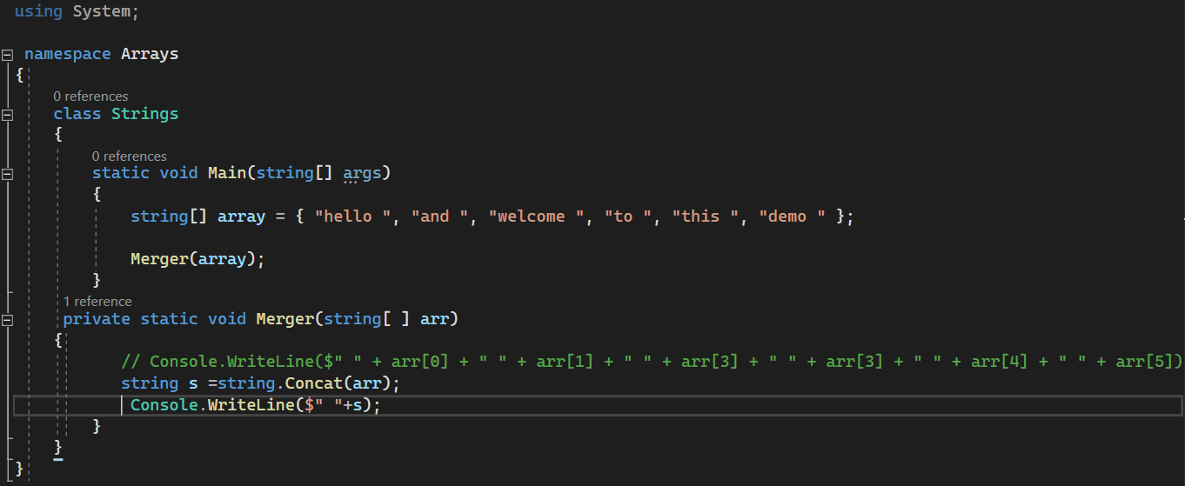

**Output :**

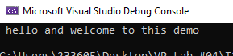

**3. Write a method which takes string as an argument and extracts all words of length between 4 to 5 and contains vowels in it. Method returns an array of type string containing words which satisfy above criteria.**

**Input :**

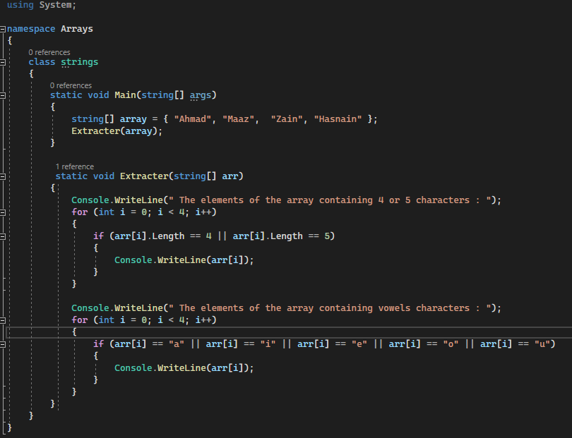

**Output :**

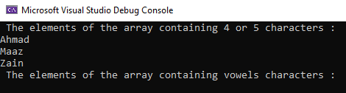

**4. Forty students were asked to rate the quality of the food in the student cafeteria on a scale of 1 to 5, with 1 being awful and 5 being excellent. Place these 40 responses in an integer array and summarize the frequency for each rating.**

**Output would look like**

**Response I given by: 0 people**

**Response 2 given by: 10 people**

**Response 3 given by: 12 people**

**Response 4 given by: 12 people**

**Response 5 given by: 6 people.**

**Input :**